**CHAPTER 1- INTRODUCTION**

**CHAPTER 1- INTRODUCTION**

What MIDI Isn’t Yes, it’s an odd place to start, but one of the things that confuses people new to MIDI is that they assume MIDI is some type of sound, or audio, that travels through MIDI cables. It’s not. What MIDI Is All of these devices rely on something called “MIDI.” You really can’t get too far with an electronic instrument without bumping into MIDI. This is actually a good thing, though, since MIDI allows you to do all sorts of exciting musical things. MIDI, which stands for “Musical Instrument Digital Interface,” is a system that allows electronic musical instruments and computers to send instructions to each other. It sounds simple, but MIDI provides some profound creative opportunities. Of course, it helps to know what MIDI is—that’s what this booklet’s for. Once you understand the basics, you can consult the documentation for your device to learn more about how it uses MIDI. When you hold down the Middle C on the keyboard, the keyboard sends out a Middle C “key down” MIDI message to the module. The module says to itself, “Ah, right, Middle C,” and plays Middle C. Why MIDI Matters Here are just some of the things MIDI makes possible:

You can use a MIDI instrument with which you’re comfortable to play Middle C the sounds belonging to any other MIDI device, including soft synths. Create rich musical textures by layering sounds from multiple MIDI devices, or assign different sounds to play in different pitch ranges. When you play a MIDI instrument, it produces data that can be captured by a MIDI “sequencer.” When the sequencer plays back the data, your original performance is recreated. Sequencers aren’t just MIDI recorders, though—they let you fix mistakes, change the pitches of your notes, fix their timing, the way they play, the sounds they use, and more. In addition, most sequencers can capture multiple performances on separate “tracks,” allowing you to build up full musical arrangements, one track at a time. The General MIDI sound set allows you to instantly play back pre-recorded music on many MIDI instruments, or on a computer.One MIDI device can control another, letting you use the most convenient tool for any job. Edit MIDI instrument sounds on your computer, operate an audio recorder from a MIDI beat box, and on and on.

When you let go of Middle C, the keyboard sends a Middle C “note off” message to the module, and the module stops playing its Middle C note. Note-on and note-off messages are just the beginning, though. Most MIDIcontrollers can also sense how hard you play a note, transmitting a MIDI “velocity” value to the receiving device so the volume or brightness of its note responds to your touch.

It’s just one MIDI device telling another one what to do. Here’s how playing a note—the most common MIDI activity—happens.Suppose you’ve got a MIDI keyboard connected to a MIDI synthesizer box, or “module,” and you want to play the module from the keyboard.

A MIDI device that controls another is referred to as a MIDI “controller.” Though most people think of MIDI as being just for keyboard players, a wide range of MIDI controllers and control surfaces make it easy for all sorts of players and engineers to harness the power of MIDI. Let’s talk about some of the available controllers just to give you some idea of the possibilities.

A steel-stringed guitar with a MIDI pickup or a dedicated MIDI guitar synthesizer can turn a guitar into a full-fledged MIDI controller of exceptional expressiveness. There are a number of other instruments and devices that use MIDI. There are specially made MIDI wind controllers, mallet controllers, and even MIDI accordions. Since MIDI was primarily designed for keyboard players, these devices are often referred to as "alternate controllers". Another category of alternate MIDI controllers are those that don't mirror traditional musical instruments. These are simple switches and controls that can be used in items as various as clothing (gloves, suites, mats), to objects that can be hit, strummed, blown, or even controlled by a light beam. Whether you’re playing the guitar synth’s own sounds or external MIDI sounds, standard guitar techniques can make MIDI sounds come alive. MIDI devices can not only be used to trigger note information, but they can also send control information to other devices, such as lighting controllers.

Electronic drum sets offer a totally natural playing experience along with incredible sounds, all without the hassles of a traditional kit. You can practice on headphones all night if you want, or record drum tracks straight into a MIDI sequencer from a drum kit’s pad and cymbal controllers. There are smaller drum controllers you can play with sticks, or even with your hands. You can also control MIDI devices from traditional acoustic drums by installing MIDI drum triggers. A MIDI sequencer can provide a tremendous amount of fun for the amateur musician, and it’s a powerful tool in the hands of a professional. In fact, sequencers play an important role in many modern commercial recordings. During recording, the sequencer captures and plays back live MIDI performances. Performances can also be constructed slowly, note-by-note, using a variety of methods that may include “step sequencing” and onscreen pencil tools that let you “draw” the notes you want. Each recorded performance is typically stored on its own track, and a sequencer may offer anywhere from 16 tracks to over a hundred.

Remember, too, that a captured MIDI performance is just a set of instructions for recreating the performance. Since it doesn’t contain any actual sound, you can choose the best sound for a performance even after it’s been recorded.

A sequencer may let you view notes in an variety of ways, from a list of MIDI products’ features, resulting in files that only their sequencers can play. This events, to a piano-roll-type view, to onscreen notation. (Many sequencers presents a roadblock for musicians who want to collaborate or otherwise also allow you to print the notation you see onscreen.) share sequencer files. The capturing of MIDI notes is just the beginning, since a sequencer allows The solution is the Standard MIDI File, or “SMF,” format.,you to do all sorts of things to perfect your music. Some of the most This standardized sequence file format allows music to commonly used sequencer tools are: travel from one sequencer to another, since most mode sequencers can play SMFs, and store songs as SMFs. An SMF may not contain all of the bells and whistles that make any one sequencer unique, but it supports the features that are common to all sequencers, and this makes them extremely handy.

• quantization—that corrects the timing of notes.

• transposition—that moves notes to new musical keys.

• scaling—that changes the feel of recorded musical phrases by adjusting

recorded velocity values, note lengths, and more.

Some instruments contain a built-in sequencer, giving you sounds and

sequencing in a single “workstation.” There are also numerous computer-

based sequencing programs and standalone hardware sequencers.

**CHAPTER 2- OVERVIEW OF PROJECT**

**CHAPTER 2- OVERVIEW OF PROJECT**

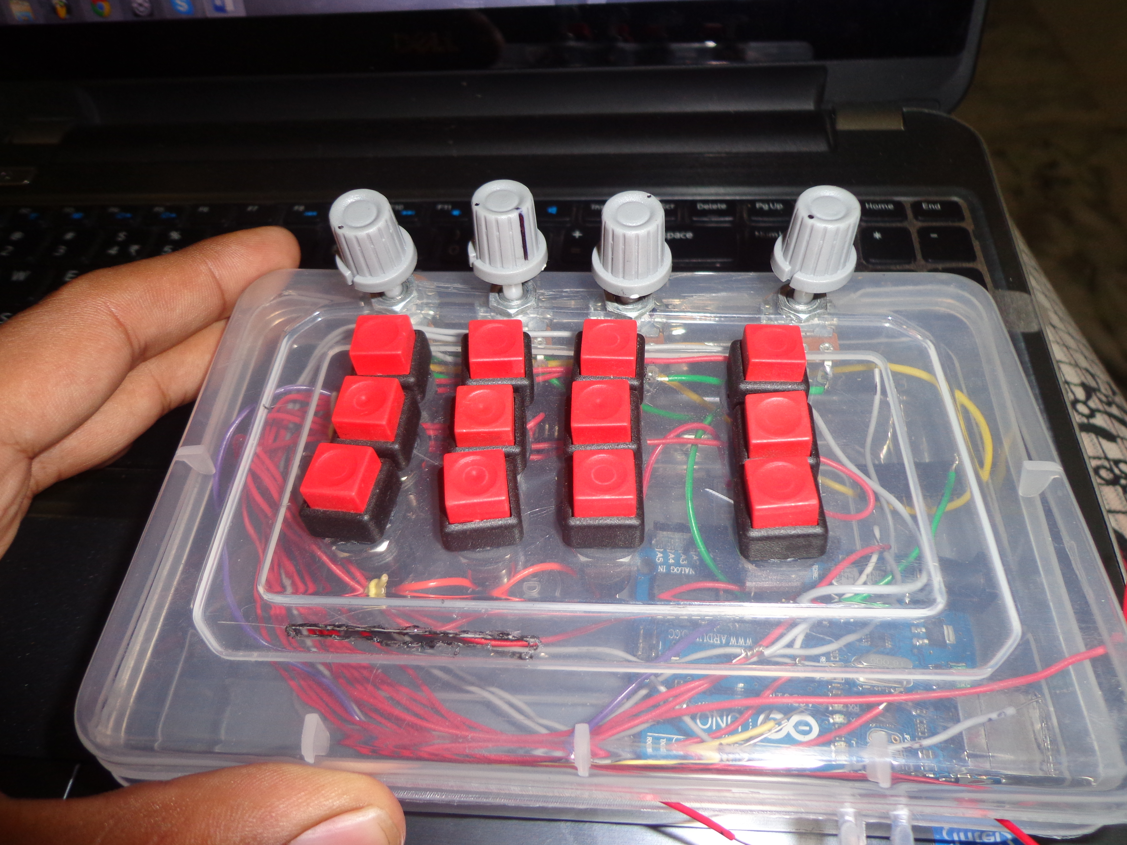

**Fig 2.1. Midi Controller**

**2.1 Digital Audio Technology**

In recent decades, digital audio (and its related industries) has evolved from being an infant technology that was available only to a select few to its present- day position as a primary driving force in audio production, entertainment,and communication. In fact, digital audio and media production has such an impact upon our lives that it’s often an integral part of both the medium and the message within modern-day communication.Although digital audio is a varied and complex field of study, the basic theory of how the process works isn’t really that difficult to understand. At its most elementary level, it is simply a process by which numeric representations of analog signals (in the form of voltage levels) are encoded, processed, stored, and reproduced over time through the use of a binary number system.Just as English-speaking humans communicate by combining any of 26 letterstogether into groupings known as ‘‘words’’ and manipulate numbers usingthe decimal (base 10) system . . . the system of choice for a digital device is thebinary (base 2) system. This numeric system provides a fast and efficientfor manipulating and storing digital data. By translating the alphabet,base 10 numbers, or other form of information into a binary form, a digitaldevice (such as a computer or processor) can perform calculations and tasksthat might otherwise be cumbersome, less cost effective, and/or downrightimpossible to perform in the analog domain. This binary data can be encodedin such media forms as:

^ Logical 1 or 0

^ On or off

^ Voltage or no voltage

After the information has been recorded, stored, and/or processed, the resulting data can beconverted back into an analogous form that we humans can readily understand.Before we delve onto the basic aspects of recording, processing, and reproducing audio in thedigital domain, let’s take a look at how one form of information can be converted into anotherequivalent (analogous) form of information. For example, if we type the letters C, A, and Tinto a word processor, the computer quickly goes about the task of translating these keystrokesinto a series of 8-bit digital words that would be represented as [0100 0011], [0100 0001],and [0101 0100]. These ‘‘alpha-bits’’ don’t have much meaning when examined individually;however, when placed together into a group, this data represents a four-legged animal that’seither seldom around or always underfoot (Figure 2.2). From this, we can deduct thatwhenever binary words are grouped together as a string of data that has an analogous andrecognizable pattern, a meaningful message can be conveyed.

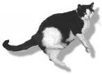

**Figure 2.2. Digital and analog equivalents for a strange four-legged animal (Conway, one of our cats).**

In a similar manner, a digital audio system works by sampling (measuring) the instantaneousvoltage level of an analog signal at a single point in time . . . and then converting these samplesinto an encoded word that digitally represents that voltage level. By successively measuringchanges in an analog signal’s voltage level (over time) . . . this stream of representativewords can be stored in a form that represents the original analog signal. Once stored, the datacan then be processed and reproduced ways that have changed the face of audio productionforever.

**2.1.1 Sampling**

In the world of analog audio, signals are passed, recorded, stored, and reproduced as changesin voltage levels that continuously change over time (Figure 2.3). The digital recording pro-cess, on the other hand, doesn’t operate in a continuous manner; rather, digital recordingtakes periodic samples of a changing audio waveform (Figure 2.4) and transforms these sampled signal levels into a representative stream of binary words that can be manipulated or stored for later processing and/or reproduction.Within a digital audio system, the sampling rate is defined as the number of measure- ments (samples) that are taken of an analog signal in one second. Its reciprocal (sampling time) is the elapsed time that occurs between each sampling period. For example, a sample rate of 48 kHz corresponds to a sample time of 1/48,000th of a second. Because sampling is tied directly to the component of time, the sampling rate of a system determines its overall bandwidth (Figure 2.5), meaning that a system with higher sample rates is capable of storing frequencies at its upper limit.

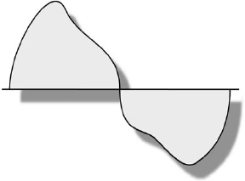

**Figure 2.3. An analog signal is continuous in nature**

. 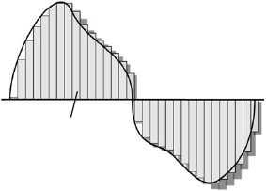

**Figure 2.4. A digital signal makes use of periodic sampling to encode information.**

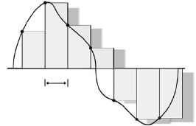

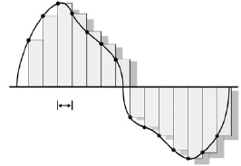

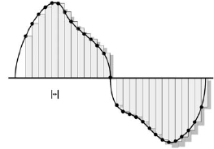

**Figure 2.5 Discrete time sampling. (a) Whenever the sample rate is set too low, important data between sample periods will be lost. (b) As the rate is increased, more frequency-related data can be encoded. (c) Increasing the sampling frequency further can encode the recorded signal with an even higher bandwidth range.**

As you might expect, the sampling process can be likened to a photographer who takes a series of shots of an action sequence. As the number of pictures taken in a second increases, the accuracy of the captured event will likewise increase . . . until the resolution is so great, that you can’t tell that the successive pictures have turned into a (hopefully) compelling movie. During the sampling process , an incoming analog signal is sampled at discrete and precisely timed intervals (as determined by the sample rate).

Figure 2.4. The sampling process. (a) The analog signal is momentarily ‘‘held’’ (frozen in time), while the converter goes about the process of determining the voltage level at that point in time and then converting that level into a binary-encoded word that’s numerically equivalent to the sampled level. (b) After the converter has stored the representative word into a memory medium, the sample is released and the next sample is held, as the system again goes about the task of determining the level of the next sampled voltage . . . and so forth, and so forth, and a so forth over time.

.467324524 Volts = (11100110 11000011)

.428566041 Volts =(11010101 00110001)

signal is momentarily ‘‘held’’ (frozen in time), while the converter goes about the process of determining what the voltage level actually is, with a degree of accuracy that’s defined by the converter’s circuitry and the chosen bit rate. The converter then generates a binary-encoded word that’s numerically equivalent to the analog level currently being sampled. Once done, the converter can store the representative word into a memory medium (tape, disk, disc, etc.), release its hold, and then go about the task of determining the level of the next sampled voltage. The process is then continuously repeated throughout the recording process.

**2.1.2 The Nyquist Theorem**

According to the Nyquist theorem, in order for the desired frequency bandwidth to be faithfully encoded in the digital domain, the selected sample rate must be at least twice as high as the highest frequency to be recorded (sample rate !2 Â highest frequency). Thus, an audio signal with a bandwidth of 20 kHz would require that the sampling rate be at least 40 kHz samples/second. 220 Modern Recording Techniques Using the ‘‘comparator’’ circuit, during each sample and hold period, the converter compares the input signal level with a given set of reference voltages (which are successively reduced in scale by one-half for each ‘‘bit’’) until an equivalent digital word has been determined. (a) If the signal is greater than the first reference voltage, the first bit gets a ‘‘1,’’ and if it’s lower than the first reference voltage, the first bit gets a ‘‘0.’’ (b) If the signal is greater than the second reference voltage, the second bit gets a ‘‘1,’’ and if it’s lower than the second reference voltage, the second bit gets a ‘‘0.’’ (c) If the signal is greater than the third reference voltage, the second bit gets a ‘‘1,’’ and if it’s lower than the second reference voltage, the second bit gets a ‘‘0.’’ (d) These comparisons continue to zero in on the precise voltage level in smaller and smaller steps until all of the bits in the digital word (in this case, an 8-bit word) have been defined . . . and the process can begin again to determine the next sample level

**2.1.3 Oversampling**

Oversampling is a process that’s commonly used in professional and consumer digital audio systems to improve a Nyquist filter’s anti-aliasing characteristics. This process has the effect of further reducing intermodulation and other forms of audible distortion. Whenever oversampling is used, the effective sampling rate within a converter’s filtering block is multiplied by a specific factor (often ranging between 12 and 128 times the original rate). This significant increase in the sample rate is accomplished by interpolating sampled level points between the original sample times. In effect, this technique makes educated guesses as to what the sample levels would be and where they’d fall at the newly generated sample time and then creates an equivalent digital word at that point. This increased sample rate likewise results in a much wider frequency bandwidth (so much so that a simple, less-expensive filter can be used to cut off the frequencies above the Nyquist limit). By down-sampling the rate back to its original value after the filter block, the Nyquist filter’s bandwidth will be narrowed to such a degree that it approximates a much more complex and expensive cutoff filter.

**2.1.4 Quantization**

Quantization represents the amplitude component of the digital sampling process. It is usedto translate the voltage levels of a continuous analog signal (at discrete sample points over time) into binary digits (bits) for the purpose of manipulating and/or storing audio data in the digital domain. By sampling the amplitude of an analog signal at precise intervals over time, it becomes the job of the converter to determine the exact voltage level of the signal (during the sample interval, when the voltage level is momentarily held) . and then output an analogous set of binary numbers (as a grouped word of n-bits length) that represents the originally sampled voltage level . The resulting word is used to encodes the original voltage level with as high a degree of accuracy as can be permitted by the word’s bit length and the system’s overall design.

**2.2 Modern Recording Techniques**

Currently, the most common binary word length for audio is 16-bit (for example, [0110010100101101]); however, professional systems having 20- and 24-bit resolution are also in common use. In addition, computers and signal-processing devices are capable of performing calculations internally at the 32- and 64-bit resolution level. This added internal headroom at the bit level, helps reduce errors in level and performance at low-level resolutions, whenever multiple audio datastreams are mixed and/or processed within a digital signal processing (DSP) system. This greater internal bit resolution is used as errors are most likely to accumulate within the least-significant bits (LSBs, the final and smallest numeric value within a digital word). As multiple signals are mixed together and multiplied (a regular occurrence in gain change and processing functions), lower-bit-resolution numbers become more and more of a component of the final result. . . . Since the internal bit depth is higher, these resolutions can be preserved (instead of being dropped within the hard- or software processing function) . . . with a final result being an n-bit datastream that’s relatively free of errors.This leads us to the conclusion that greater word lengths will often directly translate into an increased resolution (and thus higher quality) due to the added number of finite steps into which a signal can be digitally encoded. The following details the number of encoding steps that are encountered for the most commonly used bit lengths:

8-bit word 1⁄4 (nnnnnnnn) 1⁄4 256 steps

16-bit word 1⁄4 (nnnnnnnnnnnnnnnn) 1⁄4 65,536 steps

20-bit word 1⁄4 (nnnnnnnnnnnnnnnnnnnn) 1⁄4 1,048,576 steps

24-bit word 1⁄4 (nnnnnnnnnnnnnnnnnnnnnnnn) 1⁄4 16,777,216 steps

32-bit word 1⁄4 (nnnnnnnnnnnnnnnnnnnnnnnnnnnnnnnn) 1⁄4 4,294,967,296 steps

where n 1⁄4 binary 0 or 1. Signal-to-Error Ratio

Although analog signals are continuous in nature, as we’ve read, the process of quantizing a signal into an equivalent digital word isn’t. Since the number of discrete steps that can be encoded within a digital word limits the accuracy of the quantization process, the represen- tative digital word can only be an approximation (albeit an extremely close one) of the original analog signal level. A digital system’s signal-to-error ratio is closely akin (although not identical) to the analog concept of signal-to-noise (S/N) ratio. Whereas a S/N ratio is used to indicate the overall dynamic range of an analog system, the signal-to-error ratio of a digital audio device indicates the degree of accuracy that’s used with regard to a signal level’s accuracy and its step-related effects of quantization. Given a properly designed system, the signal-to-error ratio for a signal coded with n bits is: Signal-to-error ratio 1⁄4 6n þ 1:8(dB) Therefore, the theoretical signal-to-error ratios for the most common bit rates will yield a dynamic range of:

8-bit word 1⁄4 49:8 dB

16-bit word 1⁄4 97:8 dB

20-bit word 1⁄4 121:8 dB

24-bit word 1⁄4 145:8 dB

32-bit word 1⁄4 193.8 dB

When you come right down to it, the fundamental difference between digital audio and analog audio is one of resolution. Theoretically, the resolution of an analog signal is infinite in both its time and level components, whereas digital audio represents both time (sampling) and level (quantization) as discrete and quantifiable steps. Although these steps are quite small, they add a ‘‘squared off’’ component to a waveform that adds distortions and sonic properties that are similar to that of a square wave. This characteristic (which occurs at the digitized signal’s least significant bit level) has the audible effect of adding low levels of harmonic distortion to the encoded signal; however, by adding a small amount of noise (whose frequency spectrum has been shaped so as to be as unobtrusive and unnoticeable as possible), it’s possible to statistically improve the resolution of the conversion process below LSB level. You heard that right . . . by adding a small amount of random noise into the A/D path, we can actually:

^ Improve the resolution of the conversion process below the least significant bit level.

^ Reduce harmonic distortion in a way that greatly improves the signal’s performance.

In order to look between the LSB steps, let’s use an analogy to understand how the process works in its basic form.

Seen as falling between either the ‘‘0’’ or ‘‘1’’ value. Without dither, if the actual voltage level to be sampled falls at any point between these LSB values, there will be a 50% chance that it will end up being indiscriminately encoded as either a ‘‘0’’ or a ‘‘1.’’ Whenever dither is added, the random element of noise will create a probability curve that allows the A/D circuit to detect whether the lower-level signal is closer to the least significant ‘‘0’’ or ‘‘1.’’ Without going much further into the process, suffice it to say that dither is mathematically determined to provide the most accurate results at the LSB level from a statistical perspective.

In addition to the above, it is also a basic truth that whenever a high-resolution signal is reduced in resolution a quantization error will be introduced into that signal. In short, whenever a signal is converted to a lower-resolution signal, dither should be employed in order to reduce or avoid artifacts that would otherwise be introduced whenever bits are truncated (the simple dropping of lower value bits when converting to a lower-resolution bit rate). This hold true when digitally converting or mixing between any bit-rate structure. For example:

^ When internally mixing at one rate and outputting at another lower-resolution rate (hopefully, dithering is provided within the DSP mix processing function)

^ When converting 24 to 20 bits, 24 to 16 bits, 20 to 16 bits, etc. (in these cases, dithering can be added via a hardware or plug-in processing module)

^ Transferring an analog tape to a 24 or 16 bit rate (in this case, dithering is naturally added via the tape noise as well as the converter’s internal thermal noise)

**2.3 The Recording Process**

In its most basic form, the digital recording chain includes a low-pass filter, a sample-and-hold circuit, an analog-to-digital converter, and the circuitry for signal coding and error correc- tion. At the input of a digital sampling system, the analog signal must be band-limited with a low-pass filter so as not to allow frequencies that are greater than half the sample rate frequency to pass into the A/D conversion circuitry. Such a stop-band (anti-aliasing) filter generally makes use of a roll-off slope at its high-frequency cutoff point (as an immediate or ‘‘brickwall’’ slope would introduce severe signal distortion and phase shifts). In order for the full bandwidth to be accurately encoded, the Nyquist theorem requires that a sampling rate be chosen that’s higher than twice the highest frequency to be recorded. For example, a system with a bandwidth that reaches into the 20-kHz range is often sampled at a rate of at least 44.1K samples per second.

Following the low-pass filter, a sample-and-hold (S/H) circuit holds and measures the analog voltage level for the duration of a single sample period, which is determined by the sample rate (i.e., less than 1/44,100th of a second). At this point, computations must be performed in order to translate the sampled level into an equivalent binary word. This step in the A/D conversion is a critical component of the digitization process, as the sampled DC voltage. Time level must be accurately quantized into an equivalent digital word (to the nearest step level) in a very short period of time. Once the sampled signal has been converted into an equivalent digital form, the data must be conditioned for further data processing and storage. This conditioning includes data coding, data modulation, and error correction. In general, the binary digits of a digital bitstream aren’t directly stored onto a recording medium as raw data; rather, data coding is used to translate the data (along with synchronization and address information) into a form that allows the data to be most efficiently and accurately stored. The most common form of digital audio data coding is pulse-code modulation, or PCM .

The density of stored information within a PCM recording and playback system is extremely high . . . so much so that any imperfections (such as dust, fingerprints, or scratches that might adhere to the surface of any magnetic or optical recording medium) will cause severe or irretrievable errors to be generated. In order to keep these errors within acceptable limits, several forms of error correction will be used (depending upon the media type). One method uses redundant data in the form of parity bits and check codes, in order to retrieve and/or reconstruct lost data; a second uses error correction that involves interleaving techniques (whereby data is deliberately scattered across the digital bitstream, according to a complex mathematical pattern). The latter has the effect of spreading the data over a larger surface of the recording media . . . thereby making the recording media less susceptible to the effects of dropouts

**2.3.1 The Reproduction Process**

In many respects, the digital reproduction chain works in a manner that is complementary to the digital encoding process. Since most digital media encodes data onto media in the form of highly saturated magnetic transition states or optical reflections, the recorded data must first be reconditioned in a way that restores the digital bitstream back into its original, modulated binary state. Once this is done, the data can then be de-interleaved (reassembled) back into its original form, where it can be converted back into PCM data.

Once the signal has been reconstructed back into its original PCM form, the process of digital- to-analog (D/A) conversion can take place. Often, a stepped resistance network (sometimes called an R/2R network) is used to convert the representative words back into their analogous voltage levels within the playback phase. During a complementary sample-and-hold period, each bit within the word being converted is assigned to a leg in the network (moving from the most-significant to the least-significant bit). Each leg is designed to pass one-half the reference voltage level that can be passed by the previous step . The presence or absence of a logical ‘‘1’’ in each step is then used to turn on each successive voltage leg. As you might expect, summing together these voltages will yield a precise level that can be passed on to the converter’s analog output. Following the conversion process, a final, complementary low-pass filter is inserted into the signal path. This filter is used to smooth out any nonlinear steps that are introduced by the sampling process . . . resulting in a waveform that will faithfully represent the originally recorded analog waveform (assuming that the circuit has been properly designed).

**2.4 Digital Audio Transmission**

In this digital age, it’s become increasingly common for audio data to be distributed from one device to another or throughout a connected production system in the digital domain. In this way, digital audio can be transmitted in its original numeric form and (in theory) without any 2R Reference voltage

**2.4.1 AES/EBU**

The AES/EBU (Audio Engineering Society and the European Broadcast Union) protocol has been adopted for the purpose of transmitting digital audio between professional digital audio devices. This standard (which is most often referred to as simply an ‘‘AES’’ digital connection) is used to convey two channels of interleaved digital audio through a single, three- pin XLR microphone cable in a single direction. This balanced configuration connects pin 1 to the signal ground, while pins 2 and 3 are used to carry signal data. AES/EBU transmission data is low impedance in nature (typically 110 #) and has digital burst amplitudes that range between 3 and 10 V. These combined factors allow for a maximum cable length of up to 328 feet (100 meters) at sample rates of less than 50 kHz, without encountering undue signaldegradation.

Digital audio channel data and subcode information are transmitted in blocks of 192 bits that are organized into 24 words (with each being 8 bits long). Within the confines of these data blocks, two subframes are transmitted during each sample period that convey information and digital synchronization codes for both channels in an L–R–L–R . . . fashion. Because the data is transmitted as a self-clocking biphase code wire polarity can be ignored, and whenever two devices are directly connected the receiving device will usually derive its reference timing clock from the digital source device.

In the late 1990s, the AES protocol was amended to include the ‘‘stereo 96k dual AES signal’’protocol. This was created to address signal degradations that can occur when running

**2.4.2 S/PDIF**

The S/PDIF (Sony/Phillips Digital Interface) protocol has been widely adopted for transmit- ting digital audio between consumer digital audio devices and their professional counterparts (using a similar data structure). Instead of using a balanced 3-pin XLR cable, the popular S/PDIF standard has adopted the single-conductor, unbalanced phono (RCA) connector, which conducts a nominal peak-to-peak voltage levels of 0.5 V between con-nected devices, with an impedance of 75 #. In addition to using RCA wire cable connections, S/PDIF can also be transmitted between devices using Toslink optical connection lines, which are commonly referred to as ‘‘lightpipe’’ connectors.

As with the AES/EBU protocol, S/PDIF channel data and subcode information are trans-mitted in blocks of 192 bits consisting of 12 words that are 16 bits long. A portion of this information is reserved as a category code that provides the necessary setup information (sample rate, copy protection status, and so on) to the copy device. Another portion is set aside for transmitting audio data used to relay track indexing information (such as start ID and program ID numbers), allowing this relevant information to be digitally transferred from the master to the copy. It should be noted that the professional AES/EBU protocol isn’t capable of digitally transmitting these codes during a copy transfer.In addition to transmitting two channels in an interleaved L–R–L–R . . . fashion, S/PDIF is able to communicate multichannel data between devices. Most commonly, this shows up as

**2.4.3 SCMS**

Initially, certain digital recording devices (such as a DAT recorder) were intended to provide consumers with a way to make high-quality recordings for their own personal use. Soon after its inception, however, for better or for worse, the recording industry began to see this new medium as a potential source of lost royalties due to home copying and piracy practices. As a result, the RIAA (Recording Industry Association of America) and the former CBS Technology Center set out to create a ‘‘copy inhibitor.’’ After certain failures and long industry deliberations, the result of these efforts was a process that has come to be known as the Serial Copy Management System, or SCMS. SCMS (pronounced ‘‘scums’’) has been incorporated into many consumer digital devices in order to prohibit the unauthorized copying of digital audio at 44.1 kHz (the standard CD sample rate). This copy inhibitor does not apply to the making of analog copies, to digital copies that are made using the AES/EBU protocol, or to sample rates other than 44.1 kHz.

So, what is SCMS? Technically, it’s a digital protection flag that is encoded in byte 0 (bits 6 and 7) of the S/PDIF subcode area. This flag can have only one of three possible states:

^ Status 00: No copy protection, allowing unlimited copying and subsequent dubbing

^ Status 10: No more digital copies allowed

^ Status 11: Allows a single copy to be made of this product but that copy cannot be copied

Suppose that we have two DAT machines that are equipped with SCMS (with one being used for playback and the other for recording). If we try to digitally copy a DAT that has a 10 SCMS status, we would simply be out of luck; however, suppose that we found a DAT that has an 11 status flag. By definition, the bitstream data would inform the copy machine that it’s OK to record the digital signal; however, the status flag on the subsequent copy tape would then be changed to a 10 flag. If at a later time we wanted to clone this DAT copy, the machine doing the second-generation copy couldn’t be placed into Record. At that point, we have two possible choices: We could record the signal using the analog ports, or a digital format converter could be used that (among other things) allows us to strip the SCMS copy protection flags from the bitstream and continue to make multigenerational copies (it should be noted that some digital audio editors are also able to strip out or reset the protection flag bits).

**2.4.4 MADI**

The MADI (Multichannel Audio Digital Interface) standard was jointly proposed as an AES standard by representatives of Neve, Sony, and SSL as a straightforward, clutter-free digital connection interface between multitrack devices (such as a digital tape recorder or mixing console). The format allows up to 56 channels of linearly encoded digital audio to be connec- ted via a single 75-#, video-grade coaxial cable at distances of up to 120 feet (50 meters)

The transmission rate of l00 Mbit/second provides for an overall bandwidth that’s capable of handling audio data and numerous sync codes at various sample rate speeds (including allowances for changing pitch either up or down by 12.5% at rates between 32 and 48 kHz).

**2.4.5 ADAT Lightpipe**

A wide range of modular digital multitrack recorders, soundcards, and hardware devices use the Alesislightpipe system for transmitting multichannel audio via a standardized optical cable link.

Lightpipe connections make use of standard Toslink connectors and cables to transmit up to eight digital audio channels over a sequential, optical bitstream. Although these connectors are identical to those that are used to optically transmit S/PDIF stereo digital audio, the datastreams are incompatible with each other. Lightpipe data is not bidirectional in that it can only travel from a single source to a destination in one direction; therefore, two cables are needed to distribute data both to and from a device. Only digital audio data is transmitted over the serial bitstream, meaning that sync data will not be passed. Should sync be needed to lock one or more devices together (as in a multiple ADAT system or ADAT/DAW setup),separate sync cabling (often 9-pin serial connectors) will be required.

**2.4.6 TDIF**

The TDIF (Tascam Digital InterFace) is a proprietary format that uses a 25-pin D-sub cable to transmit and/or receive up to eight channels of digital audio between compatible devices. Unlike the lightpipe connection, TDIF is a bidirectional connection, meaning that only one cable is required to connect the 8 ins and outs of one device to another. Although systems that support TDIF-1 cannot send and receive sync information (a separate wordclock connection is required for that), the newer TDIF-2 protocol is capable of receiving and transmitting sync through the existing connection, without any additional cabling. One of the major problems that faces the professional and project studio is the vast number of interconnections that must be made between devices within a connected setup. Given that audio, MIDI, and sync are often routed separately within a production system, the mess can often result in a complex pile of spaghetti that’s not only cumbersome and complex . . . but can also be unreliable and extremely difficult to reconfigure. Although several proprietary network interconnections are beginning to solve this problem in the digital domain, an innovative system from Yamaha (known as mLAN ) seems to be leading the pack by allowing multichannel digital audio and MIDI music data to be transferred via a single IEEE 233 234

All of this means that a mLAN-based music system could be quickly and easily configured, saved, and recalled with none of the frustration and down time that occur when reconfiguring a conventional system. Using the patch bay application that’s provided with all Mlan products, devices can be routed and reconfigured within software. Since it’s ‘‘hot pluggable,’’ devices (called ‘‘nodes’’) can be plugged and unplugged without having to power-down or reset the system. In addition, mLAN is able to transmit and resolve world clock issues . . . even allowing devices to run at differing sample rates on the same network. Finally, this format can run with or without a computer. Should multiple mLAN hardware devices be connected, the system will establish a network link for easy connectivity.

Although Yamaha developed mLAN, it is available to other manufacturers on a royalty-free (no-cost) basis. As of this writing, over 40 manufacturers have signed on as mLAN licensees, eight manufacturers have developed first-generation products.

If copies are to be made from a single, digital audio source or if data is to be distributed throughout a connected network using AES/EBU, S/PDIF, and MADI digital transmission cables . . . it is possible to distribute the data from one device to the next in a straightforward,daisy-chain fashion This method works well only if a few devices are to be Jitter is a controversial and widely misunderstood phenomenon. To my knowledge, it’s been explained best by Bob Katz of Digital Domain (www.digido.com; Orlando, Florida). The following is a brief excerpt of his article ‘‘Everything You Always Wanted To Know About Jitter But Were Afraid To Ask.’’ Further reading on digital audio and mastering techniques can be found in Bob’s excellent book, Mastering Audio: The Art and the Science, from Focal Press ([www.focalpress.com](http://www.focalpress.com)): Jitter is time-base error. . . . It is caused by varying time delays in the circuit paths from component to component in the signal path. The two most common causes of jitter are poorly designed Phase Locked Loops (PLLs) and waveform distortion due to mismatched impedances and/or reflections inthe signal path.

Here is how waveform distortion can cause time-base distortion: The top waveform represents a theoretically perfect digital signal. Its value is 101010, occurring at equal slices of time, represented by the equally spaced dashed vertical lines. When the first waveform passes through long cables of incorrect impedance, or when a source impedance is incorrectly matched at the load, the square wave can become rounded, fast rise times become slow, also reflections in the cable can cause misinterpretation of the actual zero crossing point of the waveform. The second waveform shows some of the ways the first might change; depending on the severity of the mismatch you might see a triangle wave, a squarewave with ringing, or simply rounded edges. Note that the new transitions (measured at the Zero Line) in the second waveform occur at unequal slices of time. Even so, the numeric inter- pretation of the second waveform is still 101010! There would have to be very severe waveform distortion for the value of the new waveform to be misinterpreted, which usually shows up as audible errors—clicks or tics in the sound. If you hear tics, then you really have something to worry about. If the numeric value of the waveform is unchanged, why should we be concerned? Let’s rephrase the question: ‘‘When (not why) should we become concerned?’’ The answer is ‘‘hardly ever.’’ The only effect of time-base distortion is in the listening; as far as it can be proved, it has no effect on the dubbing of tapes or any digital-to-digital transfer (as long as the jitter is low enough to permit the data to be read; high jitter may result in clicks or glitches as the circuit cuts in and out). A typical D to A converter derives its system clock (the clock that controls the sample and hold circuit) from the incoming digital signal. If that clock is not stable, then the conversions from digital to analog will not occur at the correct moments in time. The audible effect of this jitter is a possible loss of low-level resolution caused by added noise, spurious (phantom) tones, or distortion added to the signal. A properly dithered 16-bit recording can have over 120 dB of dynamic range; a D to A converter with a jittery clock can deteriorate the audible dynamic range to 100 dB or less, depending on the severity of the jitter. I have performed listening experiments on purist, audiophile-quality musical source material recorded with a 20-bit accurate A/D conver- ter (dithered to 16 bits within the A/D). The sonic results of passing this signal through processors that truncate the signal at À110, À105, or À96 dB are increased ‘‘grain’’ in the image; instruments losing their sharp edges and focus; reduced sound-stage width; apparent loss of level causing the listener to want to turn up the monitor level, even though high-level signals are reproduced at unity gain. Contrary to intuition, you can hear these effects without having to turn up the listening volume beyond normal (illustrating that low-level ambience cues are very important to the quality of reproduction). Similar degradation has been observed when jitter is present. Nevertheless, the loss due to jitter is subtle and primarily audible with the highest-grade audiophile D/A converters.

**2.4.7 Wordclock**

One aspect of digital audio recording that never seems to get enough attention is the need for synchronization at the sample level within a series of interconnected digital audio devices In order to reduce such gremlins as clicks, pops, and jitter (oh my!), it’s often necessary to lock the overall sample rate timing to a single master clock signal (so that the conversion sample and hold states for all digital audio channels and devices will occur at exactly the same point in time) . . . through the use of a single timing reference known as wordclock. As an example, let’s assume that we’re in a room that has four or five clocks, and none of them reads the same time! In places like this, you never quite know what the time really is . . . the clocks could be running at different speeds or at the same speed but are ticking at different times. Basically, trying to accurately keep track of the time while simultaneously looking at all of the clocks would end up being a jumbled nightmare. On the other hand, if all of these clocks were locked to a single, master clock (remember those self-correcting clocks that have been installed in most schools?) . . . keeping track of the time (even when moving from room to room) would be much simpler. In effect, wordclock works in a similar fashion. If the sample clock (the timing reference that determines the sample rate and DSP traffic control) for each device was set to operate in a freewheeling, internal fashion . . . the timing references of each device within the connected digital audio chain wouldn’t accurately match up. Even though the devices are all running at the same sample rate, these resulting mismatches in time will often result in clicks, ticks, excessive jitter, and other unwanted grunge. In order to correct for this, the internal clocksof all the digital devices within a connected chain must be referenced to a single ‘‘master’’ wordclock timing element .

Similar to the distribution of time code, there can only be one master wordclock reference within a connected digital distribution network. This reference source can be derived from a digital mixer, soundcard . . . or any desired source that can transmit wordclock. Often, this reference pulse is chained between the involved devices through the use of BNC and/or RCA connectors, using low-capacitance cables (often 75-#, video-grade coax cable is used, although this cable grade isn’t always necessary on shorter cable runs). It’s interesting to note that wordclock isn’t generally needed when making a digital copy from one device to another (via such protocols as AES, S/PDIF, MADI, or TDIF2),

**CHAPTER 3- HARDWARE & COMPONENTS REQUIRED**

**CHAPTER 3- HARDWARE & COMPONENTS REQUIRED**

**SNO PART NAME QUANTITY**

1. Resisters 1

2. Large Prototype PCBs 1

3. ATMEGA 8 Microcontroller 1

4. 22pF ceramic capacitors(ceramic disc) 2

5. 28 pin IC socket 1

6. Female& Male Connector 16

7. Wire Band1 16

8. 5v power supply (Adaptor) 1

**3.1 RESISTORS:**

A resistor is a passive two-terminal electrical component that implements electrical resistance as a circuit element.The current through a resistor is in direct proportion to the voltage across the resistor's terminals. This relationship is represented by Ohm's law: where I is the current through the conductor in units of amperes, V is the potential difference measured across the conductor in units of volts, and R is the resistance of the conductor in units of ohms.The Figure Is shown below:

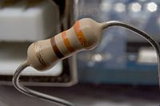

**Figure 3.1: Physical Representation Of Resistor**

The ratio of the voltage applied across a resistor's terminals to the intensity of current in the circuit is called its resistance, and this can be assumed to be a constant (independent of the voltage) for ordinary resistors working within their ratings .Resistors are common elements of electrical networks and electronic circuits and are ubiquitous in electronic equipment. Practical resistors can be made of various compounds and films, as well as resistance wire (wire made of a high-resistivity alloy, such as nickel-chrome). Resistors are also implemented within integrated circuits, particularly analog devices, and can also be integrated into hybrid and printed circuits. The electrical functionality of a resistor is specified by its resistance: common commercial resistors are manufactured over a range of more than nine orders of magnitude. When specifying that resistance in an electronic design, the required precision of the resistance may require attention to the manufacturing tolerance of the chosen resistor, according to its specific application. The temperature coefficient of the resistance may also be of concern in some precision applications. Practical resistors are also specified as having a maximum power rating which must exceed the anticipated power dissipation of that resistor in a particular circuit: this is mainly of concern in power electronics applications. Resistors with higher power ratings are physically larger and may require heat sinks. In a high-voltage circuit, attention must sometimes be paid to the rated maximum working voltage of the resistor. Practical resistors have a series inductance and a small parallel capacitance; these specifications can be important in high-frequency applications. In a low-noise amplifier or pre-amp, the noise characteristics of a resistor may be an issue. The unwanted inductance, excess noise, and temperature coefficient are mainly dependent on the technology used in manufacturing the resistor. They are not normally specified individually for a particular family of resistors manufactured using a particular technology. A family of discrete resistors is also characterized according to its form factor, that is, the size of the device and the position of its leads (or terminals) which is relevant in the practical manufacturing of circuits using them.

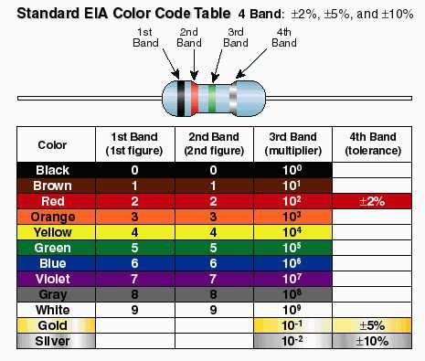

**Figure 3.2: Color Coding Of Resistor**

**3.2PROTOTYPE PCB:**

A printed circuit board, or PCB, is used to mechanically support and electrically connect electronic components using conductive pathways, tracks or signal traces etched from copper sheets laminated onto a non-conductive substrate. It is also referred to as printed wiring board (PWB) or etched wiring board. Printed circuit boards are used in virtually all but the simplest commercially produced electronic devices.

A PCB populated with electronic components is called a printed circuit assembly (PCA), printed circuit board assembly or PCB Assembly (PCBA). In informal use the term "PCB" is used both for bare and assembled boards, the context clarifying the meaning.

Alternatives to PCBs include wire wrap and point-to-point construction. PCBs must initially be designed and laid out, but become cheaper, faster to make, and potentially more reliable for high-volume production since production and soldering of PCBs can be automated. Much of the electronics industry's PCB design, assembly, and quality control needs are set by standards published by the IPC organization.



**Figure 3.3: Prototype PCB**

**3.3 ATMEGA-8 MICROCONTROLLER :** The **AVR** is a modified Harvard architecture 8-bit RISC single chip microcontroller which was developed by Atmel in 1996. The AVR was one of the first microcontroller families to use on-chip flash memory for program storage, as opposed to one-time programmable ROM,EPROM, or EEPROM used by other microcontrollers at the time. The ATMEGA8 member has many features similar to that of ATMEGA32 . But it has reduced number of features and capabilities, yet it has enough features to work with. Now let me tell you that if you want to gather knowledge and at the same time want to do it in less cost than the budget of ATMEGA32, you can think of making projects with ATMEGA8 . In that case, one feature you won’t be able to realize is theJTAG Interface. But rest of the features are available in this IC. Let us see what one can get from ATmega8.

**Memory:** It has **8 Kb** of Flash program memory (10,000 Write/Erase cycles durability), **512 Bytes** of EEPROM (100,000 Write/Erase Cycles). **1Kbyte** Internal SRAM

**I/O Ports:** 23 I/ line can be obtained from three ports; namely Port B, Port C and Port D.

**Interrupts:**  Two External Interrupt source, located at port D. 19 different interrupt vectors supporting 19 events generated by internal peripherals.

**Timer/Counter:** Three Internal Timers are available, two 8 bit, one 16 bit, offering various operating modes and supporting internal or external clocking.

**SPI (Serial Peripheral interface):** ATmega8 holds three communication devices integrated. One of them is Serial Peripheral Interface. Four pins are assigned to Atmega8 to implement this scheme of communication.

**USART:**One of the most powerful communication solutions isUSART and ATmega8 supports both synchronous and asynchronous data transfer schemes. It has three pins assigned for that. In many projects, this module is extensively used for PC-Micro controller communication.

**TWI (Two Wire Interface):** Another communication device that is present in ATmega8 is Two Wire Interface. It allows designers to set up a commutation between two devices using just two wires along with a common ground connection, As the TWI output is made by means of open collector outputs, thus external pull up resistors are required to make the circuit.

**Analog Comparator:** A comparator module is integrated in the IC that provides comparison facility between two voltages connected to the two inputs of the Analog comparator via External pins attached to the micro controller.

**Analog to Digital Converter:**Inbuilt analog to digital converter can convert an analog input signal into digital data of **10bit** resolution. For most of the low end application, this much resolution is enough.

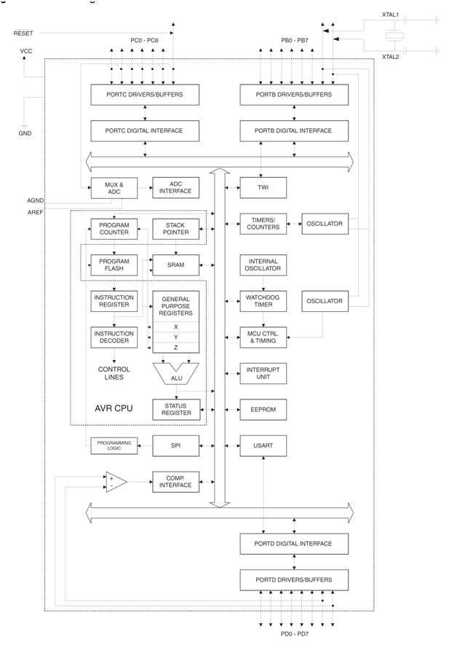

**Figure 3.4: Atmega8 Microcontroller Architecture**

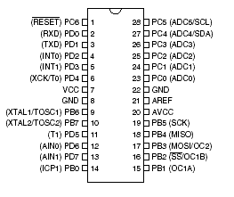

**Figure 3.5: ATMEGA8 PINS**

**3.4 CIRAMIC CAPACITOR:**

A ceramic capacitor is a fixed capacitor with the ceramic material acting as the dielectric. It is constructed of two or more alternating layers of ceramic and a metal layer acting as the electrodes. The composition of the ceramic material defines the electrical behavior and therefor the application of the capacitors which are divided into two stability classes:

* Class 1 ceramic capacitors with high stability and low losses for resonant circuit application.
* Class 2 ceramic capacitors with high volumetric efficiency for buffer, by-pass and coupling applications.

Ceramic capacitors, especially the multilayer version (MLCC), are the most produced and used capacitors in electronic equipment with a produced quantity of approximately 1000 billion pieces per year.

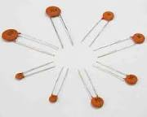

**Figure 3.6: Ceramic Capacitor**

Three classes of ceramic capacitors are commonly available:

* Class I capacitors: accurate, temperature-compensating capacitors. They are the most stable over voltage, temperature, and to some extent, frequency. They also have the lowest losses. On the other hand, they have the lowest volumetric efficiency. A typical class I capacitor will have a temperature coefficient of 30 ppm/°C. This will typically be fairly linear with temperature. These also allow for high Q filters—a typical class I capacitor will have a dissipation factor of 0.15%. Very high accuracy (~1%) class I capacitors are available (typical ones will be 5% or 10%). The highest accuracy class 1 capacitors are designated C0G or NP0.
* Class II capacitors: better volumetric efficiency, but lower accuracy and stability. A typical class II capacitor may change capacitance by 15% over a −55 °C to 85 °C temperature range.
* Class III capacitors: high volumetric efficiency, but poor accuracy and stability. A typical class III capacitor will change capacitance by -22% to +56% over a temperature range of 10 °C to 55 °C. It will have a dissipation factor of 4%. It will have fairly poor accuracy (commonly, 20%, or +80/-20%). These are typically used for decoupling or in other power supply applications.

At one point, Class IV capacitors were also available, with worse electrical characteristics than Class III, but even better volumetric efficiency. They are now rather rare and considered obsolete, as modern multilayer ceramics can offer better performance in a compact package. These correspond roughly to low K, medium K, and high K. Note that none of the classes are "better" than any others—the relative performance depends on application. Class I capacitors are physically larger than class III capacitors, and for bypassing and other non-filtering applications, the accuracy, stability, and loss factor may be unimportant, while cost and volumetric efficiency may be. As such, Class I capacitors are primarily used in filtering applications, where the main competition is from film capacitors in low frequency applications, and more esoteric capacitors in RF applications. Class III capacitors are typically used in power supply applications. Traditionally, they had no competition in this niche, as they were limited to small sizes. As ceramic technology has improved, ceramic capacitors are now commonly available in values of up to 100 µF, and they are increasingly starting to compete with electrolytic capacitors, where ceramics offer much better electrical performance at prices that, while still much higher than electrolytic, are becoming increasingly reasonable as the technology improves**.**

**3.5 IC SOCKET:**

In microelectronics, a dual in-line package (DIP or DIL) is an electronic device package with a rectangular housing and two parallel rows of electrical connecting pins. The package may be through-hole mounted to a printed circuit board or inserted in a socket.A DIP is usually referred to as a DIPn, where n is the total number of pins. For example, a microcircuit package with two rows of seven vertical leads would be a DIP14. The photograph at the upper right shows three DIP14 ICs.IC sockets are wonderful things for three reasons:

* Sockets keep you from accidentally overheating ICs during soldering (you solder to the socket, and plug the IC in later).
* Sockets allow for easy replacement of ICs if you "let the smoke out" of one.
* Sockets are cheap (they only cost a few cents each).
* Sockets can also be used to fit in resistors or capacitors to test different values.

Note that you can avoid the clutter of noise-filtering capacitors (between Vcc and ground legs of your ICs) if you buy IC sockets with power filtering capacitors built in.

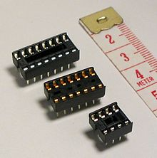

**Figure 3.7: IC Sockets**

**3.6 FEMALE & MALE CONNECTOR:**

Although the gender of tubing and plumbing fittings is usually obvious, this may not be true of electrical connectors because of their more complex and varying constructions. Instead, connector gender is conventionalized and thus can be somewhat obscure to the uninitiated. For example, the female D-subminiature connector body projects outward from the mounting plane of the chassis, and this protrusion could be erroneously construed as male. Instead, the "maleness" of the D-subminiature connectors is defined by specific presence of male pins, rather than by the protrusion of the connector, which is also true for many other pin-based connectors like XLR. The male/female distinction is more obvious with ring crimp lug connectors which are placed around a screw post, but again with spade or split ring crimp lug connectors the end alone is not obviously female.Further confusion can be caused by the term "jack", which is used for both female and male connectors and typically refers to the fixed (panel) side of a connector pair. IEEE STD 100 and ANSI Y32.16 (identical to IEEE 200-1975 and replaced by ASME Y14.44-2008) define "Plug" and "Jack" by location or mobility, rather than gender. A connector in a fixed location is a jack, and a moveable connector is a plug. The distinction is relative, so a portable radio is considered stationary compared to the cable from the headphones; the radio has a jack, and the headphone cable has a plug. Where the relationship is equal, such as when two flexible cables are connected, each is considered a plug and annotated with the P reference designator. It is common practice to use female connectors for jacks, so the informal gender-based usage often happens to agree with the functional description of the technical standards. However, this is not always the case; often-seen exceptions include a computer's AC Power Inlet and EIA232 DE9 Serial Port, or the male coaxial power jacks for connecting external power adapters to portable equipment.



**Figure 3.8: Female Connector**

**3.7 WIRE BAND:**

A wire is a single, usually cylindrical, flexible strand or rod of metal. Wires are used to bear mechanical loads and to carry electricity and telecommunications signals. Wire is commonly formed by drawing the metal through a hole in a die or draw plate. Standard sizes are determined by various wire gauges. The term wire is also used more loosely to refer to a bundle of such strands, as in 'multistranded wire', which is more correctly termed a wire rope in mechanics, or a cable in electricity.Although usually circular in cross-section, wire can be made in square or flattened rectangular cross-section, either for decorative purposes, or for technical purposes such as high-efficiency voice coils in loudspeakers. Edge-wound coil springs, such as the "Slinky" toy, are made of special flattened wire.When Wires connected together forms a Wire Band as Shown Below:



**Figure 3.9: Wire Bnad**

**3.8 5V REGULATED POWER SUPPLY:**

A regulated power supply is an embedded circuit, or stand alone unit, the function of which is to supply a stable voltage (or less often current), to a circuit or device that must be operated within certain power supply limits. The output from the regulated power supply may be alternating or unidirectional, but is nearly always DC (Direct Current).The type of stabilization used may be restricted to ensuring that the output remains within certain limits under various load conditions, or it may also include compensation for variations in its own supply source. The latter is much more common today.Most of the circuits in Electronics in Meccano need a smooth DC power supply in order to function correctly. Some other circuits, particularly those using digital ICs, also need their power supply to be regulated. In this article and the articles that follow in this series you will learn the meaning of terms such as 'smoothing' and 'regulation' and find out how to build a simple power supply for your circuits.

**3.8.1 What is AC and DC?**

A representation of an Alternating Current (AC) supply is shown in figure 1. The voltage (and current) alternates between positive and negative over time and the resulting waveform shape is a sine wave. In the case of the UK mains supply, the frequency of this sine wave is 50Hz, or 50 cycles per second.

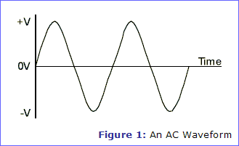

**Fig. 3.9.1- An Ac Waveform**

A Direct Current (DC) supply, shown in figure 2, stays at a fixed, regular, voltage all of the time, like the voltage from a battery. A DC supply is needed by most circuits as a constant reference voltage. Also, some components would be damaged by the negative half-cycles of an AC supply.

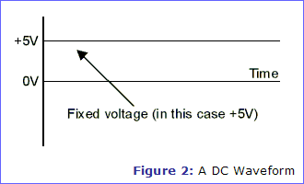

**Fig 3.9.2 A DC Waveform**

**3.8.2 THE PARTS OF POWER SUPPLY:**Figure 3 shows a block diagram of a power supply system which converts a 230V AC mains supply (230V is the UK mains voltage) into a regulated 5V DC supply.

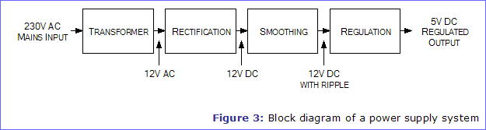

**Fig: 3.9.3 Block Diagram Of A Power Supply System**

A simple power supply circuit that includes each of these blocks in given in figure 4. The following articles in this series look at each block of the power supply in detail, but if you just want to build a 5V regulated power supply without understanding how it works, you can follow the instructions later in this article.

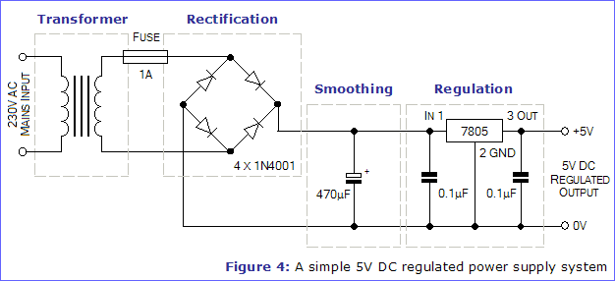

**Figure 3.10: 5V Regulated Power Supply**

**CHAPTER 4-BUILDING THE PROJECT**

**CHAPTER 4- BUILDING THE PROJECT**

In order to make a nice looking Touch screen Interface, it is important that it is completely symmetrical. The easiest way to accomplish this is to create a temporary soldering jig/template.

**1)**Test all The Components used.

**2)**Solder all the components according to the Circuit used.

**3)**Test the Circuit for its supply & other outputs.

**4)**Use a sharp pointy Solder for soldering Small Components.

**5)**Burn The Program into the Microcontroller.

**Wiring**

[[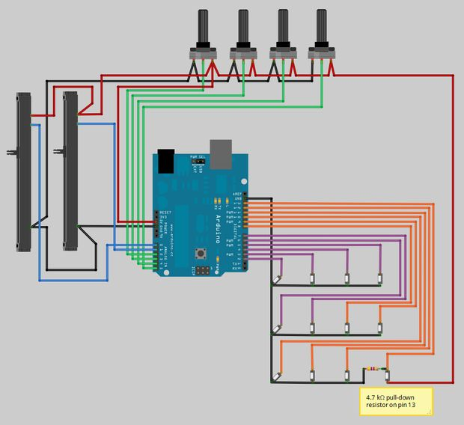](http://cdn.instructables.com/FZJ/8DYZ/GJHV8UN8/FZJ8DYZGJHV8UN8.LARGE.jpg)](http://cdn.instructables.com/FZJ/8DYZ/GJHV8UN8/FZJ8DYZGJHV8UN8.LARGE.jpg)

**Fig 4.1 Circuit**

With all of the components securely fitted inside the enclosure, it's time to work out what needs to be wired where.

[[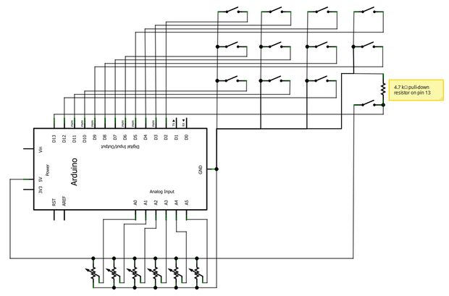](http://cdn.instructables.com/FOV/7PBW/GJHVD7F9/FOV7PBWGJHVD7F9.LARGE.jpg)](http://cdn.instructables.com/FOV/7PBW/GJHVD7F9/FOV7PBWGJHVD7F9.LARGE.jpg)

**Fig.4.2 Circuit diagram**

The ATMega328 chip used on the Arduino contains internal pull-up resistors, so we won't need to wire individual resistors for each of the arcade buttons. This greatly simplifies the controller wiring. So all that needs to be done to wire the arcade buttons is to solder one leg to ground, and connect the other leg to one of the digital inputs on the Arduino board.  
  
That said, pin 13 can not be used as a digital input with the internal pull-up resistor. See the pullup resistors section in the Digital Pins article on the Arduino website for the reasons why. For this pin we'll be using an external pull-down resistor. If you're unsure what a pull-up/pull-down resistor does, check out this great tutorial onladyada.net .  
  
Wiring the potentiometers requires a ground wire, a wire to the one of the Arduino analogue inputs, and a third +5V wire. As the potentiometer is rotated or adjusted, the resistance of the potentiometer changes between the ground and +5V wire. According to Ohm's law, voltage = current*resistance, so with a constant input current and a variable input resistance, the output voltage will be variable. It's this variable voltage that the Arduino reads on the analogue pins.  
  
The attached wiring diagram (created with the great [Fritzing](http://fritzing.org/) software) shows how to wire up each of the components to the Arduino board. The black wire represents ground, the red wire represents +5V, the purple and orange wires are digital inputs to the Arduino, and the blue and green wires are analogue inputs to the Arduino. Note that the ground wires and +5V wires have been bridged between the buttons and potentiometers.  
  
Before proceeding to the next step you may find it helpful to print out a copy of the wiring diagram to refer to whilst you solder.

## Soldering

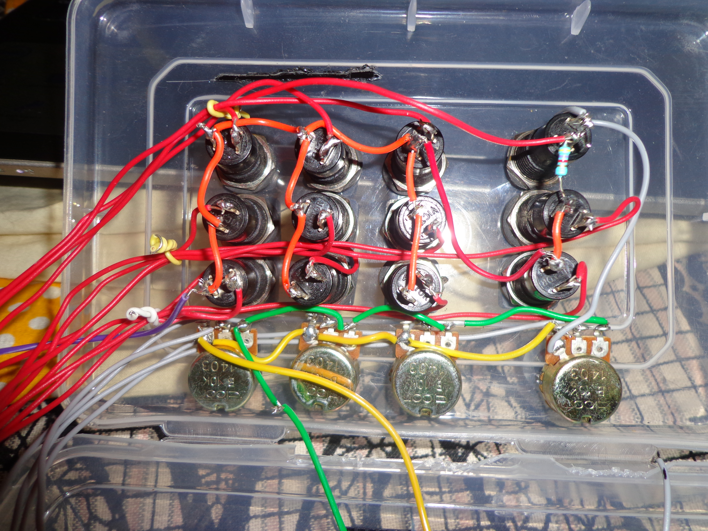

**Fig 4.3- Soldering**

Plug in your soldering iron if you haven't already. Once it's nice and hot, tin the tip of the iron (melt a bit of solder on to it, and then wipe it off on a damp sponge). It's a good idea to do this after each wire/joint you solder. Now tin all of the legs of the potentiometers and arcade buttons.  
  
We'll start by soldering all of the ground connections to the potentiometers. Cut a length of black wire approximately 80mm long, and two more lengths approximately 50mm long. Strip about 8mm of the insulation from each end of the wires. Now line up one end of each wire, and twist the copper of all three wires together. We'll be attaching this group of wires to pin one of the top left rotary potentiometer. The 80mm wire will then go to the ground pin of the Arduino, while the other two wires will go to the adjacent rotary and sliding potentiometers.  
  
Tin the twisted end of the trio of wires with some solder so the wires are fused together. Don't solder it to the potentiometer yet though!  
  
Cut a short length of heat shrink tubing (about 12mm) and slide it over the twisted end of the wires, making sure it's at least 20mm from the exposed copper and solder. Now go ahead and solder the twisted wire to the potentiometer leg. Once that's done you can slide the heat shrink over the leg, protecting the soldered joint. Just leave the heat shrink loose for now, and we'll apply heat to it later once we've done all of the soldering.  
  
Now cut another 50mm length of black wire and strip each end. Line up one end of the wire with the free end of one of the 50mm wires from before. Twist the copper of the two wires together, and then tin the joint. Again don't solder the joint yet, but first cut some heat shrink and slide it over the tinned wires. Solder the twisted wires to pin one of the second rotary potentiometer and slide the heat shrink over the joint.  
  
Repeat this process for each potentiometer leg and arcade button leg, referring to the wiring diagram. Not every joint will be the same, so make sure you know what wire needs to go where. Don't solder anything to the bottom right most arcade button (on pin 13) as it's quite different and covered in the next section. When all of the ground wires and +5V wires have been soldered, roughly measure and cut the analogue and digital input wires and solder them in place. Tin the tips of the free end of each wire and insert them into the Arduino board.

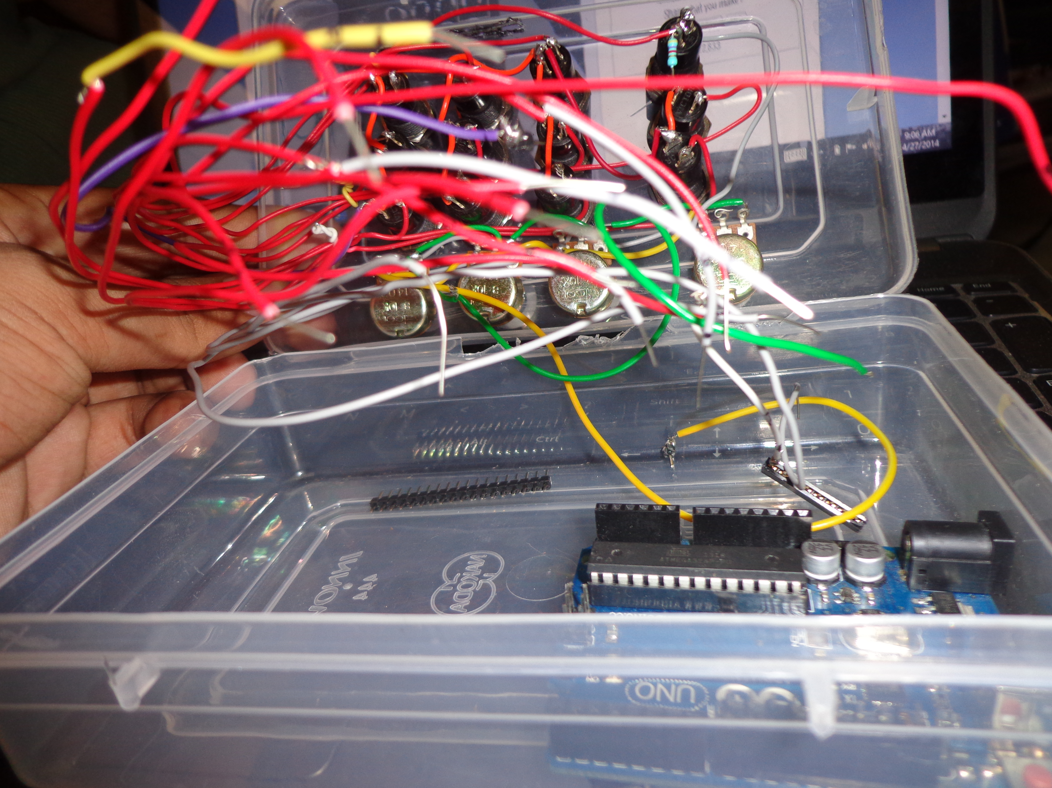

**Fig 4.4 Wiring**

**Pin 13 and the Pull-down Resistor**  
As mentioned in the previous step, pin 13 requires a pull-down resistor so it can be read by the Arduino. Referring to the wiring diagram, solder the resistor to the common (black) wire of button 11. Solder a short length of black wire to the other end of the resistor so it can reach button 12. Now twist together the end of the short black wire with the data wire which will connect pin 13 to button 12. Solder the wires together, and then solder the pair of wires to one of the legs on button 12.  
  
Run a wire from the +5V leg of rotary potentiometer four to the free leg of button 12 (see the long red wire on the right in the photo below). Solder the wire to the potentiometer and button.  
  
**Closing the enclosure**  
Sounds simple enough, but just be sure that none of the components interfere with the wires connecting to the Arduino. Note in the second photo that all of the digital input wires run to the right of the Arduino board. This allows room for the first column of arcade buttons to sit nicely above the Arduino without crushing it.  
  
You may require a little force when fitting the lid to the base. If it won't close properly, try and see what components or wires are getting in the way. You may need to bend a few button legs and rearrange some wires for it to close nicely. Once the lid is on, screw it all together with the included screws.  
  
Add the rubber feet to each corner of the base (not over the screw holes just in case you need access inside) and you're done!

**CHAPTER 5 – PROGRAMMING**

**CHAPTER 5- PROGRAMMING**

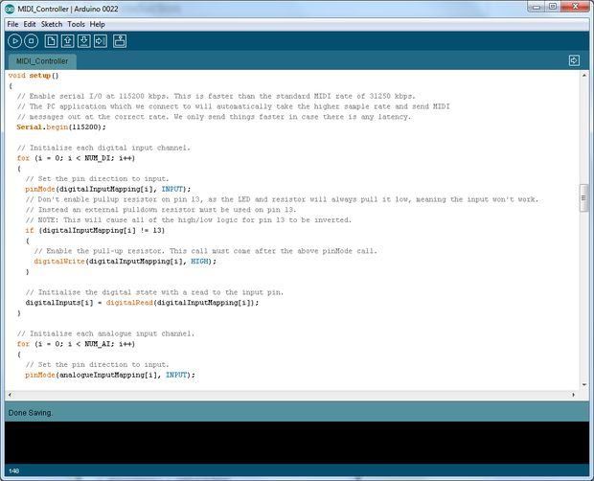

**4.5 Arduino Programmer**

Congratulations on making it this far! You must be itching to test out your very own MIDI controller.  
  
First things first, we need to program the Arduino board. If this is your first encounter with an Arduino board, you'll need to setup the Arduino IDE on your PC so it can talk to the Arduino and you can load programs on to it. To do this simply follow the [Getting Started guide](http://arduino.cc/en/Guide/HomePage) on the Arduino homepage. You will also need to install the [Timer1 library](http://arduino.cc/playground/Code/Timer1) . Download it and unzip it to /hardware/libraries/Timer1/  
  
Edit: As of MIDI_Controller_2011-03-21.zip, Timer1 is no longer needed.  
  
Once your Arduino is up and running, we'll need to load a sketch on it that reads all of the digital and analogue channels and converts that info into MIDI messages. Those MIDI messages are then sent serially over the USB cable to the PC.  
  
Download the attached sketch and upload it to your Arduino. The code has been documented so you can see what is going on. In a nutshell the code continually polls all of the digital and analogue inputs checking for changes. If a change is detected (a button was pressed or a slider was moved), a MIDI message corresponding to the input is sent to the PC.  
One thing to note is that the logic for when a button is pressed and released may seem a bit backwards. When a button is pressed the digital input goes 'low', and when it's released it goes 'high'. This is to do with the internal pull up resistor and the buttons being wired to ground in the previous step.  
When there is no input to the digital pin (no button is being pressed), the input is being pulled up, or high, hence the name. So the default state of the digital pin is high. Each button was wired to ground so that when a button is pressed, the pin will read low.

The code is written in the Arduino compiler The Code Produced Is shown below:

// Basic MIDI Controller code for reading all of the Arduino's digital and analogue inputs

// and sending them as MIDI messages to the host PC.

//

// Authors: Michael Balzer

// Teensy USB-MIDI edit: Tim Crawford

//

// Revision History:

// Date | Author | Change

// ---------------------------------------------------

// 2011-02-22 | MSB | Initial Release

// 2011-03-01 | MSB | Updated MIDI output to send same MIDI signals as official MIDI Fighter

// | | Reduced debounce length from 5ms to 2ms

// 2011-03-14 | MSB | Modified analogue input logic so only pins moved within the timer

// | | period are updated, not all of them.

// | | Experimental code added for higher speed (but less accurate) analogue reads

// | | Reduced analogue timer length from 1000ms to 250ms

// 2011-03-21 | MSB | Removed TimerOne library. Each analogue pin now maintains its own time

// | | since it was last moved, rather than one timer for all pins. This stops

// | | sending jittery movements on analogue inputs which haven't been touched.

// 2011-04-11 | TC | Teensy USB code added.

// | MSB | Updated with #defines for Arduino Mega and Teensy USB for easy compilation

// 2011-10-23 | MSB | Added default #defines for Teensy 2.0 and Teensy++ 2.0 digital pins

// | | Removed #defines for Teensy 1.0 as usbMIDI is not supported

// 2012-01-20 | MSB | Updated to support Arduino 1.0 (updated Serial.print to Serial.write)

//

//

// This work is licensed under a Creative Commons Attribution-NonCommercial-ShareAlike 3.0 Unported License.

// See http://creativecommons.org/licenses/by-nc-sa/3.0/ for license details.

#if defined(__AVR_ATmega1280__) || defined(__AVR_ATmega2560__)

#define ARDUINO_MEGA

#elif defined(__AVR_AT90USB646__)

#define TEENSY_PLUS_PLUS

#elif defined(__AVR_ATmega32U4__)

#define TEENSY_2

#elif defined(__AVR_AT90USB1286__)

#define TEENSY_PLUS_PLUS_2

#else

#define ARDUINO

#endif

// Uncomment this line to send debug messages to the serial monitor

//#define DEBUG

// Uncomment this line to enable outputs corresponding to the MIDI Fighter so MF mappings can be used in Traktor.

//#define MIDI_FIGHTER

//#define FASTADC

// defines for setting and clearing register bits

#ifndef cbi

#define cbi(sfr, bit) (_SFR_BYTE(sfr) &= ~_BV(bit))

#endif

#ifndef sbi

#define sbi(sfr, bit) (_SFR_BYTE(sfr) |= _BV(bit))

#endif

// MIDI mapping taken from http://www.nortonmusic.com/midi_cc.html

#define MIDI_CC_MODULATION 0x01

#define MIDI_CC_BREATH 0x02

#define MIDI_CC_VOLUME 0x07

#define MIDI_CC_BALANCE 0x08

#define MIDI_CC_PAN 0x0A

#define MIDI_CC_EXPRESSION 0x0B

#define MIDI_CC_EFFECT1 0x0C

#define MIDI_CC_EFFECT2 0x0D

#define MIDI_CC_GENERAL1 0x0E

#define MIDI_CC_GENERAL2 0x0F

#define MIDI_CC_GENERAL3 0x10

#define MIDI_CC_GENERAL4 0x11

#define MIDI_CC_GENERAL5 0x12

#define MIDI_CC_GENERAL6 0x13

#define MIDI_CC_GENERAL7 0x14

#define MIDI_CC_GENERAL8 0x15

#define MIDI_CC_GENERAL9 0x16

#define MIDI_CC_GENERAL10 0x17

#define MIDI_CC_GENERAL11 0x18

#define MIDI_CC_GENERAL12 0x19

#define MIDI_CC_GENERAL13 0x1A

#define MIDI_CC_GENERAL14 0x1B

#define MIDI_CC_GENERAL15 0x1C

#define MIDI_CC_GENERAL16 0x1D

#define MIDI_CC_GENERAL17 0x1E

#define MIDI_CC_GENERAL18 0x1F

#define MIDI_CC_GENERAL1_FINE 0x2E

#define MIDI_CC_GENERAL2_FINE 0x2F

#define MIDI_CC_GENERAL3_FINE 0x30

#define MIDI_CC_GENERAL4_FINE 0x31

#define MIDI_CC_GENERAL5_FINE 0x32

#define MIDI_CC_GENERAL6_FINE 0x33

#define MIDI_CC_GENERAL7_FINE 0x34

#define MIDI_CC_GENERAL8_FINE 0x35

#define MIDI_CC_GENERAL9_FINE 0x36

#define MIDI_CC_GENERAL10_FINE 0x37

#define MIDI_CC_GENERAL11_FINE 0x38

#define MIDI_CC_GENERAL12_FINE 0x39

#define MIDI_CC_GENERAL13_FINE 0x3A

#define MIDI_CC_GENERAL14_FINE 0x3B

#define MIDI_CC_GENERAL15_FINE 0x3C

#define MIDI_CC_GENERAL16_FINE 0x3D

#define MIDI_CC_GENERAL17_FINE 0x3E

#define MIDI_CC_GENERAL18_FINE 0x3F

#define MIDI_CC_SUSTAIN 0x40

#define MIDI_CC_REVERB 0x5B

#define MIDI_CC_CHORUS 0x5D

#define MIDI_CC_CONTROL_OFF 0x79

#define MIDI_CC_NOTES_OFF 0x78

#define NOTE_C0 0x00 // 0

#define NOTE_C1 0x12 // 18

#define NOTE_C2 0x24 // 36

#if defined(ARDUINO_MEGA)

// Number of digital inputs. Can be anywhere from 0 to 68.

#define NUM_DI 52

// Number of analogue inputs. Can be anywhere from 0 to 16.

#define NUM_AI 16

#elif defined(TEENSY_PLUS_PLUS)

// Number of digital inputs. Can be anywhere from 0 to 46.

#define NUM_DI 38

// Number of analogue inputs. Can be anywhere from 0 to 8.

#define NUM_AI 8

#elif defined(TEENSY_2)

// Number of digital inputs. Can be anywhere from 0 to 25.

#define NUM_DI 13

// Number of analogue inputs. Can be anywhere from 0 to 12.

#define NUM_AI 12

#elif defined(TEENSY_PLUS_PLUS_2)

// Number of digital inputs. Can be anywhere from 0 to 46.

#define NUM_DI 38

// Number of analogue inputs. Can be anywhere from 0 to 8.

#define NUM_AI 8

#else

// Number of digital inputs. Can be anywhere from 0 to 18.

#define NUM_DI 12

// Number of analogue inputs. Can be anywhere from 0 to 6.

#define NUM_AI 6

#endif

#if defined(MIDI_FIGHTER) && defined(ARDUINO)

#define MIDI_CHANNEL 3

// First note, starting from lower left button

#define NOTE NOTE_C2

// When mapping to a MIDI Fighter we need to skip a row of buttons. Set this from 0-3 to define which row to skip.

// Rows are ordered from bottom to top (same as the MIDI Fighter's button layout).

#define SKIP_ROW 2

// This pin order corresponds to the bottom left button being zero, increasing by one as we move from left to right, bottom to top

// 8 9 10 11

// 4 5 6 7

// 0 1 2 3

// This array size must match NUM_DI above.

#define DIGITAL_PIN_ORDER 10, 11, 12, 13, 6, 7, 8, 9, 2, 3, 4, 5

#else

#define MIDI_CHANNEL 1

// First note, starting from upper left button

#define NOTE NOTE_C0

// This pin order corresponds to the top left button being zero, increasing by one as we move from left to right, top to bottom

// 0 1 2 3

// 4 5 6 7

// 8 9 10 11

// This array size must match NUM_DI above.

#if defined(ARDUINO_MEGA)

#define DIGITAL_PIN_ORDER 2, 3, 4, 5, 6, 7, 8, 9, 10, 11, 12, 13, 14, 15, 16, 17, 18, 19, 20, 21, 22, 23, 24, 25, 26, 27, 28, 29, 30, 31, 32, 33, 34, 35, 36, 37, 38, 39, 40, 41, 42, 43, 44, 45, 46, 47, 48, 49, 50, 51, 52, 53

#elif defined(TEENSY_PLUS_PLUS)

#define DIGITAL_PIN_ORDER 0, 1, 2, 3, 4, 5, 6, 7, 8, 9, 10, 11, 12, 13, 14, 15, 16, 17, 18, 19, 20, 21, 22, 23, 24, 25, 26, 27, 28, 29, 30, 31, 32, 33, 34, 35, 36, 37

#elif defined(TEENSY_2)

#define DIGITAL_PIN_ORDER 0, 1, 2, 3, 4, 5, 6, 7, 8, 9, 10, 11, 12

#elif defined(TEENSY_PLUS_PLUS_2)

#define DIGITAL_PIN_ORDER 0, 1, 2, 3, 4, 5, 6, 7, 8, 9, 10, 11, 12, 13, 14, 15, 16, 17, 18, 19, 20, 21, 22, 23, 24, 25, 26, 27, 28, 29, 30, 31, 32, 33, 34, 35, 36, 37

#else

#define DIGITAL_PIN_ORDER 2, 3, 4, 5, 6, 7, 8, 9, 10, 11, 12, 13

#endif

#endif

#if defined(ARDUINO_MEGA)

#define ANALOGUE_PIN_ORDER A0, A1, A2, A3, A4, A5, A6, A7, A8, A9, A10, A11, A12, A13, A14, A15

#elif defined(TEENSY_PLUS_PLUS)

#define ANALOGUE_PIN_ORDER 0, 1, 2, 3, 4, 5, 6, 7

#elif defined(TEENSY_2)

#define ANALOGUE_PIN_ORDER 0, 1, 2, 3, 4, 5, 6, 7, 8, 9, 10, 11

#elif defined(TEENSY_PLUS_PLUS_2)

#define ANALOGUE_PIN_ORDER 0, 1, 2, 3, 4, 5, 6, 7

#else

#define ANALOGUE_PIN_ORDER A0, A1, A2, A3, A4, A5

#endif

#if defined(TEENSY_PLUS_PLUS) || defined(TEENSY_2) || defined(TEENSY_PLUS_PLUS_2)

#define LED_PIN PIN_D6

#else

#define LED_PIN 13

#endif

#define MIDI_CC MIDI_CC_GENERAL1

// Comment this line out to disable button debounce logic.

// See http://arduino.cc/en/Tutorial/Debounce on what debouncing is used for.

#define DEBOUNCE

// Debounce time length in milliseconds

#define DEBOUNCE_LENGTH 2

// Comment this line out to disable analogue filtering

#define ANALOGUE_FILTER

// A knob or slider movement must initially exceed this value to be recognised as an input. Note that it is

// for a 7-bit (0-127) MIDI value.

#ifdef FASTADC

#define FILTER_AMOUNT 3

#else

#define FILTER_AMOUNT 2

#endif

// Timeout is in microseconds

#define ANALOGUE_INPUT_CHANGE_TIMEOUT 250000

// Array containing a mapping of digital pins to channel index.

byte digitalInputMapping[NUM_DI] = {DIGITAL_PIN_ORDER};

// Array containing a mapping of analogue pins to channel index. This array size must match NUM_AI above.

byte analogueInputMapping[NUM_AI] = {ANALOGUE_PIN_ORDER};

// Contains the current state of the digital inputs.

byte digitalInputs[NUM_DI];

// Contains the current value of the analogue inputs.

byte analogueInputs[NUM_AI];

// Variable to hold temporary digital reads, used for debounce logic.

byte tempDigitalInput;

// Variable to hold temporary analogue values, used for analogue filtering logic.

byte tempAnalogueInput;

// Preallocate the for loop index so we don't keep reallocating it for every program iteration.

byte i = 0;

byte digitalOffset = 0;

// Variable to hold difference between current and new analogue input values.

byte analogueDiff = 0;

// This is used as a flag to indicate that an analogue input is changing.

boolean analogueInputChanging[NUM_AI];

// Time the analogue input was last moved

unsigned long analogueInputTimer[NUM_AI];

#ifdef DEBUG

unsigned long loopTime = 0;

unsigned long serialSendTime = 0;

#endif

void setup()

{

// Taken from http://www.arduino.cc/cgi-bin/yabb2/YaBB.pl?num=1208715493/11

#ifdef FASTADC

// set prescale to 16

sbi(ADCSRA,ADPS2) ;

cbi(ADCSRA,ADPS1) ;

cbi(ADCSRA,ADPS0) ;

#endif

// Only enable serial on the Arduino or when debugging. The Teensy board should be set as a usb-midi device so serial is not needed.

#if defined(ARDUINO) || defined(ARDUINO_MEGA) || defined(DEBUG)

// Enable serial I/O at 115200 kbps. This is faster than the standard MIDI rate of 31250 kbps.

// The PC application which we connect to will automatically take the higher sample rate and send MIDI

// messages out at the correct rate. We only send things faster in case there is any latency.

Serial.begin(115200);

#endif

// Initialise each digital input channel.

for (i = 0; i < NUM_DI; i++)

{

// Set the pin direction to input.

pinMode(digitalInputMapping[i], INPUT);

// Don't enable pullup resistor on LED_PIN, as the LED and resistor will always pull it low, meaning the input won't work.

// Instead an external pulldown resistor must be used on LED_PIN.

// NOTE: This will cause all of the high/low logic for LED_PIN to be inverted.

if (digitalInputMapping[i] != LED_PIN)

{

// Enable the pull-up resistor. This call must come after the above pinMode call.

digitalWrite(digitalInputMapping[i], HIGH);

}

// Initialise the digital state with a read to the input pin.

digitalInputs[i] = digitalRead(digitalInputMapping[i]);

}

// Initialise each analogue input channel.

for (i = 0; i < NUM_AI; i++)

{

// Set the pin direction to input.

pinMode(analogueInputMapping[i], INPUT);

// Initialise the analogue value with a read to the input pin.

analogueInputs[i] = analogRead(analogueInputMapping[i]);

// Assume no analogue inputs are active

analogueInputChanging[i] = false;

analogueInputTimer[i] = 0;

}

#ifdef DEBUG

serialSendTime = millis();

#endif

}

void loop()

{

#ifdef DEBUG

loopTime = micros();

#endif

for (i = 0; i < NUM_DI; i++)

{

#ifdef MIDI_FIGHTER

if (i >= SKIP_ROW * 4)

{

digitalOffset = i + 4;

}

else

{

#endif

digitalOffset = i;

#ifdef MIDI_FIGHTER

}

#endif

// Read the current state of the digital input and store it temporarily.

tempDigitalInput = digitalRead(digitalInputMapping[i]);

// Check if the last state is different to the current state.

if (digitalInputs[i] != tempDigitalInput)

{

#ifdef DEBOUNCE

// Wait for a short period of time, and then take a second reading from the input pin.

delay(DEBOUNCE_LENGTH);

// If the second reading is the same as the initial reading, assume it must be true.

if (tempDigitalInput == digitalRead(digitalInputMapping[i]))

{

#endif

// Record the new digital input state.

digitalInputs[i] = tempDigitalInput;

// Moved from HIGH to LOW (button pressed)

if (digitalInputs[i] == 0)

{

// All the digital inputs use pullup resistors, except LED_PIN so the logic is inverted

if (digitalInputMapping[i] != LED_PIN)

{

noteOn(MIDI_CHANNEL, NOTE + digitalOffset, 0x7F); // Channel 1, middle C, maximum velocity

}

else

{

noteOff(MIDI_CHANNEL, NOTE + digitalOffset); // Channel 1, middle C

}

}

// Moved from LOW to HIGH (button released)

else

{

// All the digital inputs use pullup resistors, except LED_PIN so the logic is inverted

if (digitalInputMapping[i] != LED_PIN)

{

noteOff(MIDI_CHANNEL, NOTE + digitalOffset); // Channel 1, middle C

}

else

{

noteOn(MIDI_CHANNEL, NOTE + digitalOffset, 0x7F); // Channel 1, middle C, maximum velocity

}

}

#ifdef DEBOUNCE

}

#endif

}

}

/*

* Analogue input logic:

* The Arduino uses a 10-bit (0-1023) analogue to digital converter (ADC) on each of its analogue inputs.

* The ADC isn't very high resolution, so if a pot is in a position such that the output voltage is 'between'

* what it can detect (say 2.505V or about 512.5 on a scale of 0-1023) then the value read will constantly

* fluctuate between two integers (in this case 512 and 513).

*

* If we're simply looking for a change in the analogue input value like in the digital case above, then

* there will be cases where the value is always changing, even though the physical input isn't being moved.

* This will in turn send out a constant stream of MIDI messages to the connected software which may be problematic.

*

* To combat this, we require that the analogue input value must change by a certain threshold amount before

* we register that it is actually changing. This is good in avoiding a constantly fluctuating value, but has

* the negative effect of a reduced input resolution. For example if the threshold amount was 2 and we slowly moved

* a slider through it's full range, we would only detect every second value as a change, in effect reducing the

* already small 7-bit MIDI value to a 6-bit MIDI value.

*

* To get around this problem but still use the threshold logic, a timer is used. Initially the analogue input

* must exceed the threshold to be detected as an input. Once this occurs, we then read every value coming from the

* analogue input (not just those exceeding a threshold) giving us full 7-bit resolution. At the same time the

* timer is started. This timer is used to keep track of whether an input hasn't been moved for a certain time

* period. If it has been moved, the timer is restarted. If no movement occurs the timer is just left to run. When

* the timer expires the analogue input is assumed to be no longer moving. Subsequent movements must exceed the

* threshold amount.

*/

for (i = 0; i < NUM_AI; i++)

{

// Read the analogue input pin, dividing it by 8 so the 10-bit ADC value (0-1023) is converted to a 7-bit MIDI value (0-127).

tempAnalogueInput = analogRead(analogueInputMapping[i]) / 8;

#ifdef ANALOGUE_FILTER

// Take the absolute value of the difference between the curent and new values

analogueDiff = abs(tempAnalogueInput - analogueInputs[i]);

// Only continue if the threshold was exceeded, or the input was already changing

if ((analogueDiff > 0 && analogueInputChanging[i] == true) || analogueDiff >= FILTER_AMOUNT)

{

// Only restart the timer if we're sure the input isn't 'between' a value

// ie. It's moved more than FILTER_AMOUNT

if (analogueInputChanging[i] == false || analogueDiff >= FILTER_AMOUNT)

{

// Reset the last time the input was moved

analogueInputTimer[i] = micros();

// The analogue input is moving

analogueInputChanging[i] = true;

}

else if (micros() - analogueInputTimer[i] > ANALOGUE_INPUT_CHANGE_TIMEOUT)

{

analogueInputChanging[i] = false;

}

// Only send data if we know the analogue input is moving

if (analogueInputChanging[i] == true)

{

// Record the new analogue value

analogueInputs[i] = tempAnalogueInput;

// Send the analogue value out on the general MIDI CC (see definitions at beginning of this file)

controlChange(MIDI_CHANNEL, MIDI_CC + i, analogueInputs[i]);

}

}

#else

if (analogueInputs[i] != tempAnalogueInput)

{

// Record the new analogue value

analogueInputs[i] = tempAnalogueInput;

// Send the analogue value out on the general MIDI CC (see definitions at beginning of this file)

controlChange(MIDI_CHANNEL, MIDI_CC + i, analogueInputs[i]);

}

#endif

}

#ifdef DEBUG

loopTime = micros() - loopTime;

// Print the loop execution time once per second

if (millis() - serialSendTime > 1000)

{

Serial.print("Loop execution time (us): ");

Serial.println(loopTime);

serialSendTime = millis();

}

#endif

}

// Send a MIDI note on message

void noteOn(byte channel, byte pitch, byte velocity)

{

// 0x90 is the first of 16 note on channels. Subtract one to go from MIDI's 1-16 channels to 0-15

channel += 0x90 - 1;

// Ensure we're between channels 1 and 16 for a note on message

if (channel >= 0x90 && channel <= 0x9F)

{

#ifdef DEBUG

Serial.print("Button pressed: ");

Serial.println(pitch);

#elif defined(TEENSY_PLUS_PLUS) || defined(TEENSY_2) || defined(TEENSY_PLUS_PLUS_2)

usbMIDI.sendNoteOn(pitch, velocity, channel);

#else

Serial.write(channel);

Serial.write(pitch);

Serial.write(velocity);

#endif

}

}

// Send a MIDI note off message

void noteOff(byte channel, byte pitch)

{

// 0x80 is the first of 16 note off channels. Subtract one to go from MIDI's 1-16 channels to 0-15

channel += 0x80 - 1;

// Ensure we're between channels 1 and 16 for a note off message

if (channel >= 0x80 && channel <= 0x8F)

{

#ifdef DEBUG

Serial.print("Button released: ");

Serial.println(pitch);

#elif defined(TEENSY_PLUS_PLUS) || defined(TEENSY_2) || defined(TEENSY_PLUS_PLUS_2)

usbMIDI.sendNoteOff(pitch, 0x00, channel);

#else

Serial.write(channel);

Serial.write(pitch);

Serial.write((byte)0x00);

#endif

}

}

// Send a MIDI control change message

void controlChange(byte channel, byte control, byte value)

{

// 0xB0 is the first of 16 control change channels. Subtract one to go from MIDI's 1-16 channels to 0-15

channel += 0xB0 - 1;

// Ensure we're between channels 1 and 16 for a CC message

if (channel >= 0xB0 && channel <= 0xBF)

{

#ifdef DEBUG

Serial.print(control - MIDI_CC);

Serial.print(": ");

Serial.println(value);

#elif defined(TEENSY_PLUS_PLUS) || defined(TEENSY_2) || defined(TEENSY_PLUS_PLUS_2)

usbMIDI.sendControlChange(control, value, channel);

#else

Serial.write(channel);

Serial.write(control);

Serial.write(value);

#endif

}

}

**Software**

[[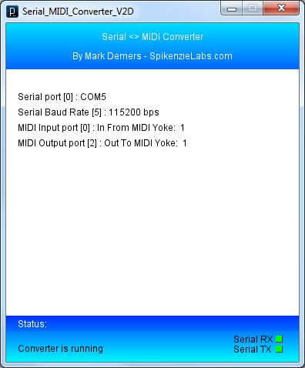](http://cdn.instructables.com/FMA/I5JM/GJQEBTXP/FMAI5JMGJQEBTXP.LARGE.jpg)](http://cdn.instructables.com/FMA/I5JM/GJQEBTXP/FMAI5JMGJQEBTXP.LARGE.jpg)

**4.6 Serial MIDI Converter**

The sketch from the previous step only sends MIDI messages over a standard serial port. To map those MIDI messages from the serial port to a MIDI port you'll need two bits of software.  
  
Firstly you need a virtual MIDI port to connect to your audio or video software. I'd recommend [MIDI Yoke](http://www.midiox.com/myoke.htm) on Windows (if you're using Vista or 7, you will need to disable UAC to install the driver). I did try using [LoopBe1](http://www.nerds.de/en/loopbe1.html) and while it works the majority of the time, the automatic feedback detection kicks in when making rapid knob/slider movements, essentially killing your MIDI control. If you're on OS X you can setup a virtual MIDI port using IAC driver under Audio MIDI Setup (there instructions at the link below).  
  
The second bit of software required converts MIDI messages coming in on a serial port to messages on a MIDI port. There are a number of software solutions to do this, but I use the simply named [Serial-MIDI Converter](http://www.spikenzielabs.com/SpikenzieLabs/Serial_MIDI.html) by SpikenzieLabs. It's Java based so will run on Windows, OS X and Linux.  
  
Once everything has been installed and setup, fire up Serial-MIDI Converter and configure it by pressing the matching letter in the list of items to match your serial and MIDI port settings. I use the settings COM 5 (yours may vary), 115200 kbps, In From MIDI Yoke 1 and Out To MIDI Yoke 1. Once you've gone through the setup, hit some of the buttons on your MIDI controller. You should see the little Serial RX and TX indicators in the bottom right of the window flash green.

**MIDI Mapping**

[Fire up your favourite audio / DJ / video software and begin mapping the controller's pots and buttons to one or more actions. This step is obviously software specific so you may need to refer the software's documentation. In general I've found that an action to perform is first selected, and then the corresponding pot or button is pressed on the controller to map the two together.](http://cdn.instructables.com/FZV/107Z/GJHV8UMW/FZV107ZGJHV8UMW.LARGE.jpg)

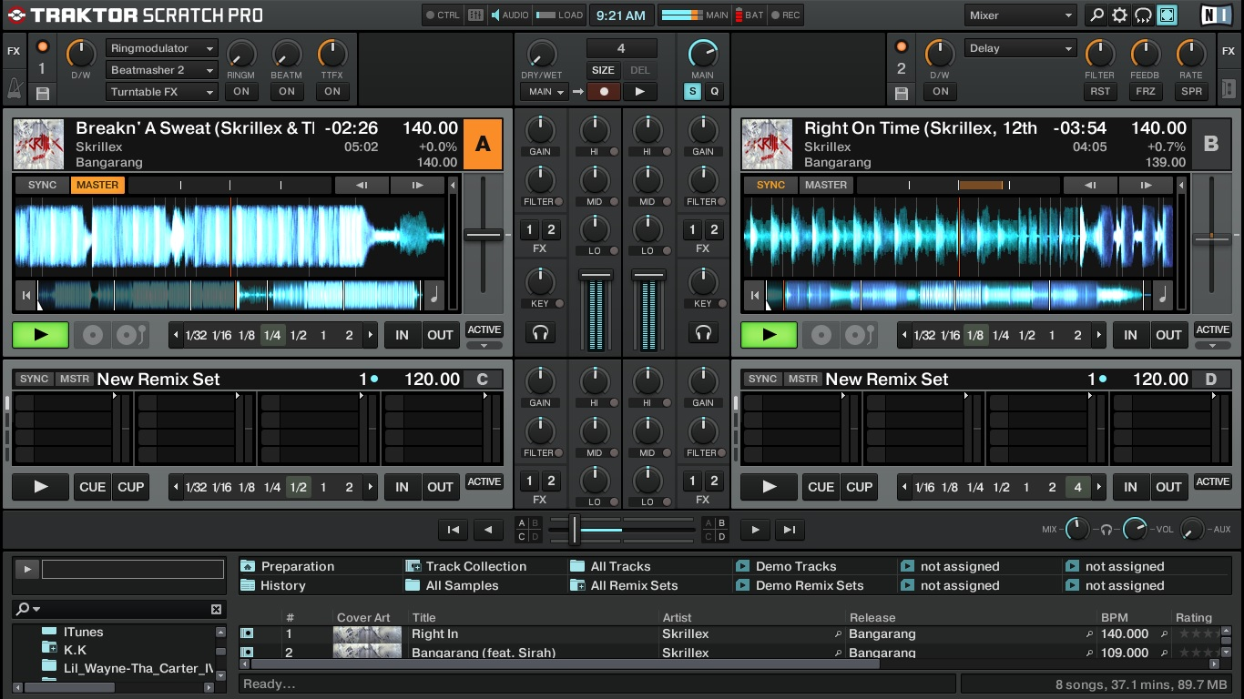

**fig 4.7- FL Studio 10**

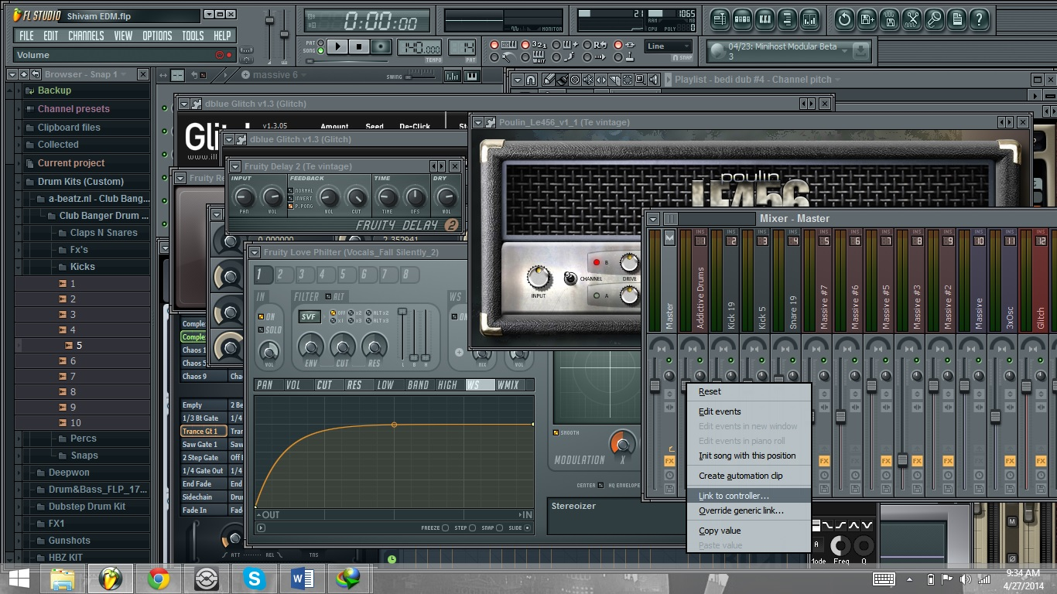

There is no limitation on what you map to where, so just experiment and play around with things until you feel comfortable. My initial controller mapping for Traktor is below. All inputs act on the selected deck, except for the two sliders.  
  
Deck A Volume - Slider 1  
Deck B Volume - Slider 2  
Chained Effect 1 Amount - Pot 1  
Chained Effect 2 Amount - Pot 2  
Chained Effect 3 Amount - Pot 3  
Effect 1 On - Button 1  
Effect 2 On - Button 2  
Effect 3 On - Button 3  
Play/Pause - Button 4  
Cue points 1-8 - Buttons 5-12

## Future Enhancements

I hope you've enjoyed creating your own MIDI controller (and my first Instructable)! Please post any suggestions or features you'd like to see in future revisions of the MIDI controller.  
  
There are a number of things I'd like to add and change in future MIDI controllers.  
  
1. Create a simple software/hardware architecture to allow for easily expandable I/O. This would be through the use of additional microcontrollers or dedicated I/O chips.  
  
2. Utilise the LUFA library to make the controller a true USB MIDI controller, and not rely on extra PC software.  
  
3. Update the Arduino sketch to support 14-bit MIDI messages  
  
4. Build a CNC machine for cutting out holes in the enclosure (you may have noticed some of the button holes I made are a bit wonky).

**CONCLUSION**

**THIS PROJECT HAVE SOME FEATURES:**

* Simple working mechanism.
* Simple to use.
* Rigid & simple Circuitry.
* It is cheap & can be used to develop further Wireless applications.
* Can be used for home & office use also.

**BIBLOGRAPHY**

[WWW.INSTRUCTABLES.COM](http://WWW.INSTRUCTABLES.COM)

[WWW.WIKIPEDIA.COM](http://WWW.WIKIPEDIA.COM)

[WWW.ALLABOUTCIRCUITS.COM](http://WWW.ALLABOUTCIRCUITS.COM)

[WWW.JEMICOELECTRONICS.COM](http://WWW.JEMICOELECTRONICS.COM).

[WWW.INTEL.COM](http://WWW.INTEL.COM)

[WWW.HOBBYPROJECTS.COM](http://WWW.HOBBYPROJECTS.COM)

[WWW.ELECTROKITS.COM](http://WWW.ELECTROKITS.COM)

[WWW.COOLCIRCUIT.COM](http://WWW.COOLCIRCUIT.COM)

[WWW.ELECTROSCHEMATICS.COM](http://WWW.ELECTROSCHEMATICS.COM)